**INVESTIGATION AND REPORT-ON-DROP-IN USER ENGAGEMENT**

A short case study investigating a drop in user engagement featuring a faux dataset of Yammer's user database from Mode Analytics. <https://community.modeanalytics.com/sql/tutorial/a-drop-in-user-engagement/>

Yammer is a freemium enterprise social networking service used for private communication within organizations. Access to a Yammer network is determined by a user's internet domain so that only individuals with approved email addresses may join

**The problem**

You show up to work Tuesday morning, September 2, 2014. The head of the Product team walks over to your desk and asks you what you think about the latest activity on the user engagement dashboards. You fire them up, and something immediately jumps out:

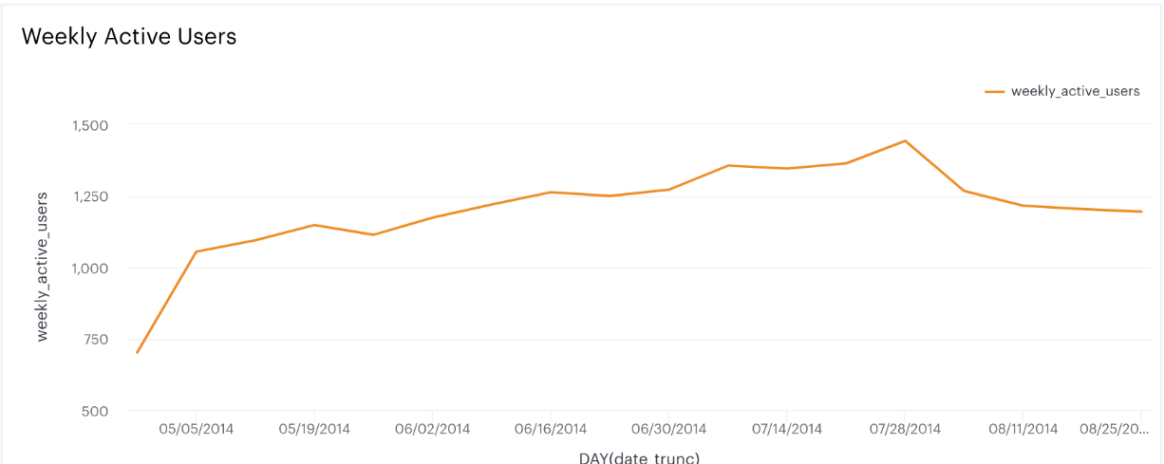

**Potential problems**

After putting the problem into context, a collection of possible problem was put together for evaluation

1. **Holiday** – Vacation could be a possible reason for the low usage of yammer, this would be accessed by checking if there are significant changes in the usage range across countries.
2. **Competition** – It is also possible is that users of yammer has shifted their interest to other products that are similar to yammer, hence the low engagement.
3. **Marketing and content quality**: A third possible reason for a dip in user’s engagement could be the quality of marketing activities and content on yammer itself.
4. **Technical issue with website:** I will also consider if this is anyhow related to issues with accessibility to the website.

**Holiday**

From the graph, there is no a major drop in engagement among user from a particular Country, hence there is nothing to prove that users engagement might be as a result of a public vacation in any Country.

Let’s consider the next possibility.

**Competition**

I would think that if a substitute product is favored among users, there would be a significant reduction in not only the engagement with Yammer, but also with the sign ups. However, from the graph below, since we are having relatively more new users, it means it can hardly be the case that another product is drawing the attention of current and potential subscribers.

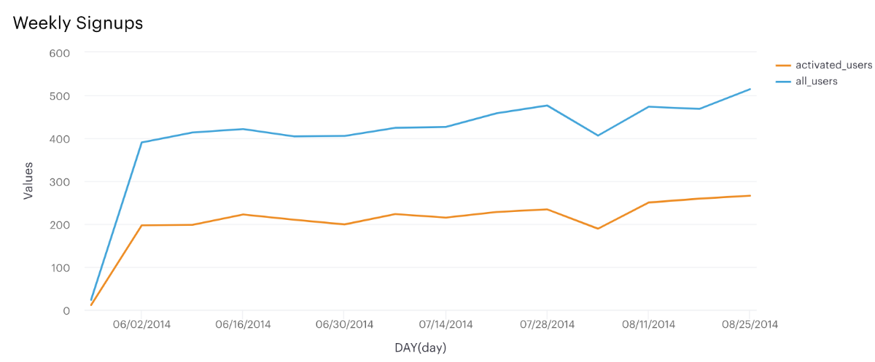

Now let’s see if there is a sharp drop in a particular type of engagement.

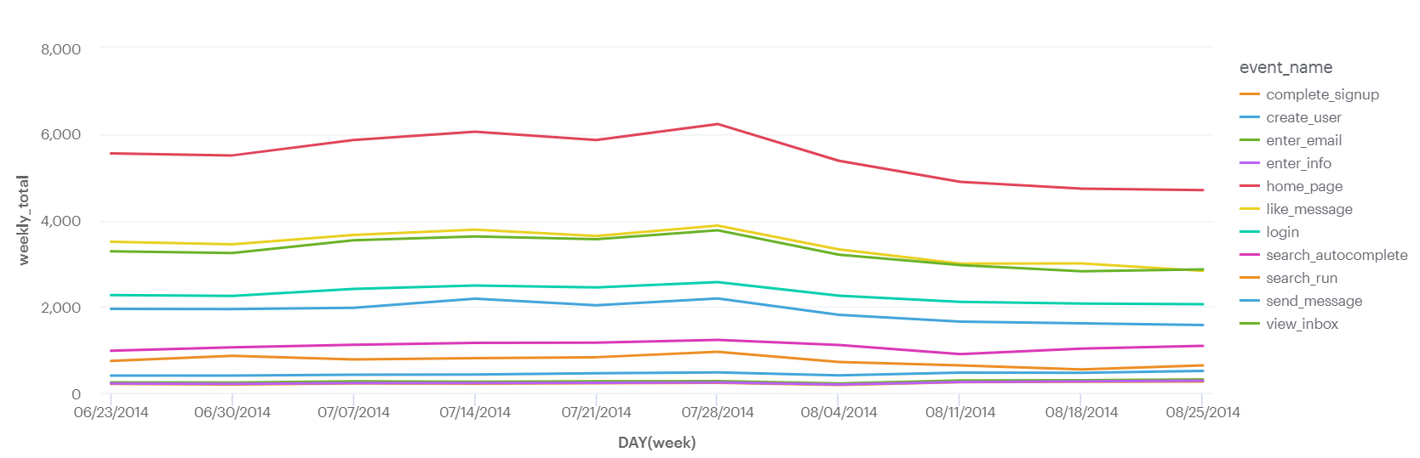

It’s clear that there has been a major drop in all kind of engagement aside creating new account. For a start, people do not login as frequently as they used to and visit to the homepage which use to be very high has significantly reduced. It appears a pull factors or features that generate traffic to the page in previous months are no longer there. Which leads us to our next possibility of checking how marketing activities has influenced user’s engagement.

**Marketing Campaign and Quality of Content**

At first glance we could see a drop off in the email click through, which validates my assumption that emails which are meant to generate traffic to the page are no longer driving engagement. That is, users are opening the links of and interacting with the weekly email digest less frequently, than they did when they joined.

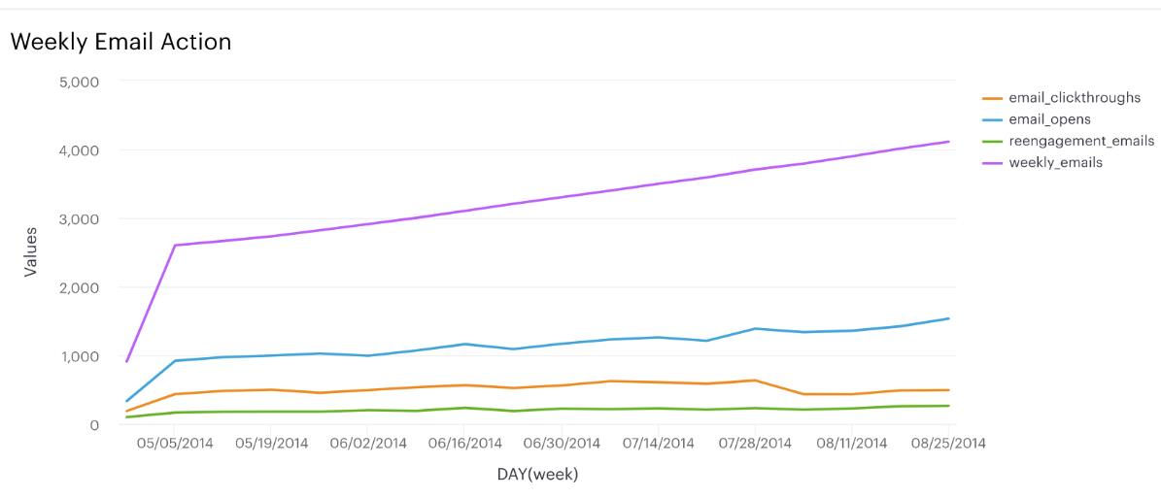

Upon further investigation, it was seen that new users interact with yammer system exponentially immediately after their registration, then after a while, their interactions gradually begin to reduce. More obvious is that it has become a trend that the older the users the lesser their engagement. This points to an assumption that the weekly email digest might at the initial stage attract users, new ones especially, it hasn’t been able to retain them.

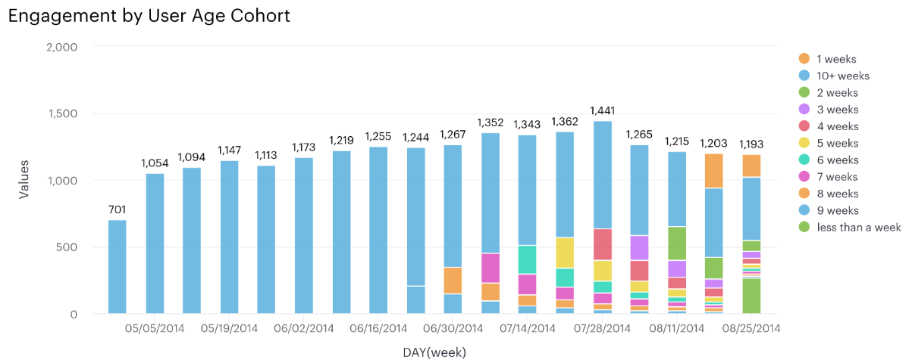

Interestingly, the engagement numbers has remained relatively constant despite a reoccurring reduction in engagement by older users. This is because new users are making up for the poor engagement of the older ones, not until sometimes in July did we see an unusual fall in the engagement level.

However, in late August, the loss in engagement uncharacteristically outpaced newer user's engagement, could it have been slightly affected by a general or a particular device’s performance on the website? Let’s find out

**Technical Issues:**

We can observe a sharp drop with users of Tablets and phone, while that of other computer was marginally affected, it is safe to conclude that it's likely that there's a problem with accessing the site or mobile app on this devices

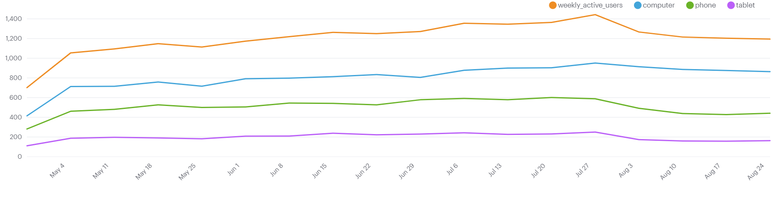

**Conclusion**

In summary, four potential causes for the dip in engagement were explored. It was concluded that the first cannot be a potential cause, while the second also seem unlikely and trivia at best. According to data, the forth which appears to be a bug with a particular device is a potential cause, but the most plausible reason is that the marketing and content quality of weekly email digest and other marketing material are not interesting enough to retain old users.

**Recommendations**

1. Get feedback from users on the type and form of content (such as the weekly email digest) they would like to read and generate accordingly.
2. Adopt a more effective marketing approach that improves users attraction to the page
3. Investigate and correct any form of access issue with all devices and ensure future occurrence are prevented.

**SQL Code**

**1. Weekly Engagement by Country for the Quarter**

Select DATE_TRUNC('week', occurred_at) as Date, location, count(event_name) as Engagements from tutorial.yammer_events

group by location, date

**Weekly subscription of activated and inactivated subscribers**

Select DATE_TRUNC('week', created_at) as Date, state,

count(case when state = 'active' then 1 END) as Active_User,

count(case when state = 'pending' then 1 End) as Pending_User

from tutorial.yammer_users

group by state, date

order by Date desc

**Weekly interaction by engagement type**

Select DATE_TRUNC('week', occurred_at) as period, event_name, count(event_name) as No_of_Occurence from tutorial.yammer_events

where event_name not in ('search_click_result_1', 'search_click_result_2', 'search_click_result_3', 'search_click_result_4',

'search_click_result_5', 'search_click_result_6', 'search_click_result_8', 'search_click_result_9', 'search_click_result_10')

group by period, event_name

order by period desc

**Weekly subscription of activated and inactivated subscribers**

Select DATE_TRUNC('day', created_at) as day, count(company_id) as All_users, count(activated_at) as Activated_Users from tutorial.yammer_users

group by day

order by day desc

**Weekly interaction with email**

SELECT cast(date_trunc('week', occurred_at) as date) AS week,  
Count(CASE WHEN event_name IN ('login') THEN user_id ELSE NULL END) AS login,   
Count (CASE WHEN event_name IN ('home_page') THEN user_id ELSE NULL END) AS homepage,   
Count (CASE WHEN event_name IN ('view_inbox','like_message','send_message') THEN user_id ELSE NULL END) AS message,   
Count (CASE WHEN event_name IN ('search_autocomplete', 'serach_run', 'search_click_result_1','search_click_result_2','search_click_result_3','search_click_result_4','search_click_result_5','search_click_result_6','search_click_result_7','search_click_result_8','search_click_result_9','search_click_result_10') THEN user_id ELSE NULL END) AS search_click   
FROM tutorial.yammer_events   
GROUP BY 1

**Weekly interaction by Device Type**

SELECT device,  
CASE WHEN device in ('iphone 5','iphone 4s','iphone 5s','nexus 5','samsung galaxy s4','htc one','nokia lumia 635','samsung galaxy note','amazon fire phone') THEN 'Phone'  
WHEN device in ('windows surface','kindle fire','ipad mini','samsumg galaxy tablet','ipad air','nexus 7','nexus 10') THEN 'Tablet'  
WHEN device in ('dell inspiron notebook','macbook air','macbook pro','lenovo thinkpad','acer aspire notebook','asus chromebook','acer aspire desktop','mac mini','hp pavilion desktop','dell inspiron desktop') THEN 'Desktop'   
END AS device_type  
FROM tutorial.yammer_events),